Great Bradley Church, Suffolk: Grave Number 119

Angus (Jack) Chapman
Jack ran the village Post Office in the 1960s (now called willow cottage)

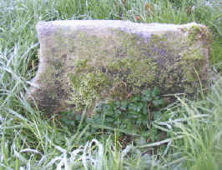 | SMALL ROUND STONE WITH ONE RIBBED SIDE;  ROUND HOLLOWED CENTRE FOR FLOWERS

